**4.4 Texture exposition**

The dictionary description is "something composed of closely interwoven elements". Practically, the human attempts the individual elements if the number of them may be counted. If the number is large it is difficult to characterize these elements individually and they merge into less distinct homogeneous spatial repeated patterns which can be called as texture.

The exposition of texture takes place under four main headings:

**(i) Texture primitives.** (Texture may be described as being composed of elements of texture primitives)

For highlight the importance of the texture primitives the term texel (for texture element) is used. A texel is a visual primitive with certain invariant properties which occurs repeatedly in different positions, deformations, and orientations inside a given area (for example, property of such a unit might be that its pixels have a constant gray level)

Texture primitives may be pixels or aggregates of pixels such as curve segments or regions. The idea of appropriate resolution, or number of texels in a sub-image is implicit part of quantitative definition of texture.

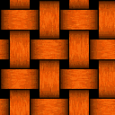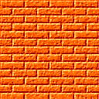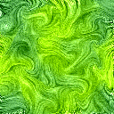

Examples of textures

**(ii) Structural models.** (Structural models regards the primitives as forming a repeating pattern and describes such patterns in terms of rules or grammar). The grammar describes how to generate patterns by applying rewriting rules to a small number of symbols. There is no unique grammar for a given texture - infinitely many choices for rules and symbols.

There are many variants of the basic idea of formal grammars: shape grammar (8 rules to describe the texture), tree grammar (85 rules for the same texture), array grammar, etc. In the shape grammar the high-level primitives closely correspond to the shapes in the texture. In the tree and arrays grammars the texels are defined as pixels and this makes the grammar more complicated.

**(iii) Statistical models** (Statistical models describes texture by statistical rules governing the distribution and relation of gray levels).

The statistical analysis of texture implies computing the distribution of certain property (gray level, average value, deviation, dispersion, entropy...) for each pixel of the image. According the number of points defined a texture the statistics of the first, second, and upper order are distinguished.

*1. First order statistics*

If the histogram of image is divided by total number of pixels the result represents the probability that the certain gray level appears in the image. Thus the following related properties may be estimated.

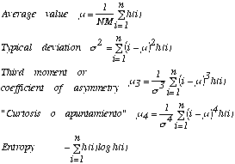

The average represents the gray level estimation, typical deviation shows the dispersion with respect this value, third moment is measurement of asymmetry of the histogram. The \_\_\_ (la curtosis o apuntamiento) indicates how the histogram is distributed in the central part and the extreme sides. The entropy measures the uniformity of the histogram.

Another way for analysis of texture is comparison of two histograms according the Kolmogorov-Smirnov test. For this the accumulative distribution of histogram *H1(k)* is used which then is compared with the accumulative distribution of histogram *H2(k)* of image with ideal texture:

*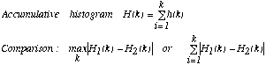*

Disadvantage the first order statistics is analysis based on the histogram which is not operate with all spatial data (only probability of gray levels). That is why the second order statistics is used.

*2. Second order statistics*

a) Co-occurrence matrixes

For the vector with polar coordinates  *=(r, )*, the conditional probability *P* that two properties appear separated by distance  may be calculated. The co-occurrence matrixes are computed taking into account certain limitations, for example, the *r* value is *1* (one pixel), angles are *0°, 45°,90°,* and *135°*).

Example. For following image (if *r=1* and  *=0°)* the *P (3,1)=3* because three pairs *3-1* are found in the image. Then the matrix *P (i,j)* is computed (*i* and *j* are properties, in the example, they are the gray levels: 0,1,2, and 3). First row is calculated as probability that two properties (gray levels from 0 to 3) have the distance *r=1* at the angle  *=0°: P (0,0)=4; P (1,0)=0; P (2,0)=1; P (3,0)=0.* The first column is computed as : *P (0,0)=4; P (0,1)=1; P (0,2)=1; P (0,3)=2.*

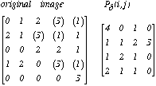

Some other properties may be extracted from the obtained matrix:

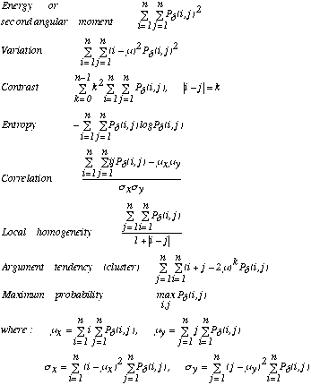

The second angular moment indicates the homogeneity of the image, the contrast - variation within the image, correlation - linearity of the image, entropy - uniformity of the matrix.

b) Difference statistics

This analysis is determined by the distribution of probability *P (k)* of values of intermediate pixels which lie between ones separated by distance  *.* It is given as:

C:\Documents and Settings\khec\Desktop\chap3\433_files\Image44_8.gif

The properties of this distribution are

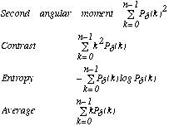

**(iv) Frequency analysis of the texture**

The Fourier transform may be used for texture analysis. If the Fourier transform of an image f(x,y) is F(u,v) its module is:

C:\Documents and Settings\khec\Desktop\chap3\433_files\Image44_10.gif

If the polar coordinates are used two distribution may be obtained:

C:\Documents and Settings\khec\Desktop\chap3\433_files\Image44_11.gif

The first distribution indicates the dominated sizes of texture, the second - its direction.

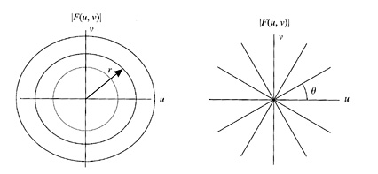

Determination of texture by Fourier *|F(u,v)|*

Some examples of the texture determination by Fourier are shown :

*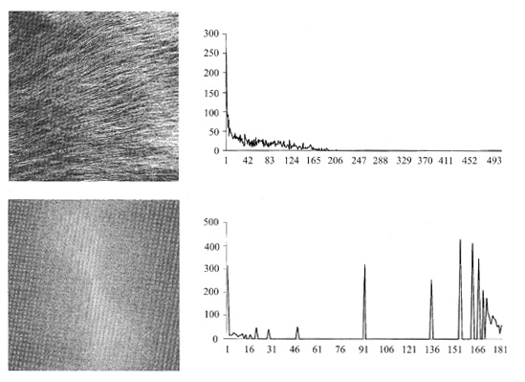*

*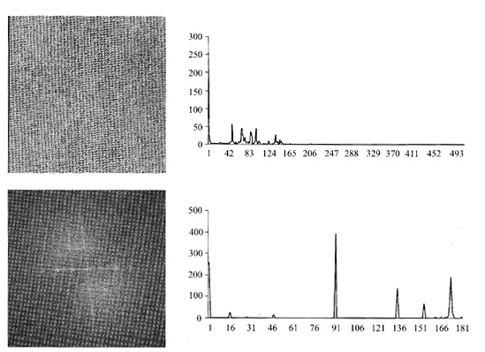*

*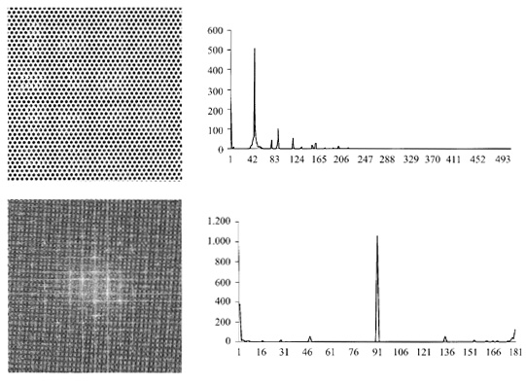*

*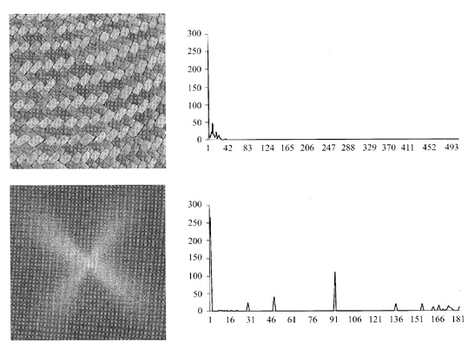*

Texture determination by Fourier transform

**(v) Texture gradients** (Texture gradients are used for determining the direction of greatest change in size of primitives and spatial placement of primitives).

The important point of the texture analysis is determining the surface orientation. There are three ways assumed that texture is embedded on a planar surface.

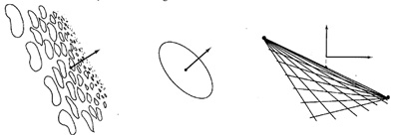

Methods for calculation surface orientation from texture.

The first, the texture is segmented into primitives and then the direction of maximum rate of change of projected primitive size is computed as the direction of the texture gradient. The magnitude of gradient determines how much the plane is tilted with respect to camera.

The second way to measure surface orientation is by knowing the shape of the textel itself. For example, a circular textel appears as ellipse on the tilted surface. The orientation of the principal axes defines rotation with respect to the camera, and the ratio of minor to major axes defines tilt.

The third, if the texture is composed of a regular grid of texels, the vanishing points are computed. For a perspective image, vanishing points on a plane are the projection onto the image plane of the points at infinity in given direction. In the figure the texels themselves are small line segments on a plane that are oriented in two orthogonal directions in the physical world.

The general method applies whenever the placement tessellation defines lines of textels. Two vanishing points that arise from texels on the same surface can be used to determine orientation as follows. The line joining the vanishing points provides the orientation of the surface and the vertical position of the plane with respect to the z axis (i.e. the intersection of the joining the vanishing points with x=0) determines the tilt of the plane.